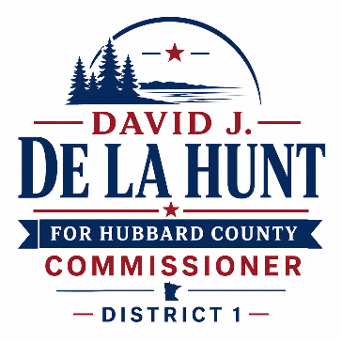FOR IMMEDIATE RELEASE

David J. De La Hunt Announces Re-Election Campaign
HUBBARD COUNTY, MN — David J. De La Hunt has announced his candidacy for re-election as Hubbard County Commissioner for District 1, pledging to continue providing experienced leadership, fiscal responsibility, and a strong voice for local communities.
"Hubbard County is a special place to live, work, raise a family, and enjoy Minnesota's great outdoors," said De La Hunt. "I am seeking re-election to continue protecting our quality of life while ensuring county government remains accountable to taxpayers."
A lifelong resident and former business owner with deep roots in the community, De La Hunt has focused his service on listening to residents, asking tough questions, and making decisions that balance growth with responsible stewardship of taxpayer resources.
During his time on the County Board, De La Hunt helped lead the transition to a professional county administrative model, supported the adoption of long-term strategic and capital improvement plans, helped establish the County Economic Development Authority, and worked to secure more than $12 million in grant funding through local economic development efforts.
He has also supported workforce housing and childcare initiatives, helped create the Walker Ambulance District, advocated for the development of Deep Lake Park, and worked with residents to develop balanced short-term rental regulations. In addition, as a member of the Heritage Campus Board, he helped stabilize operations after the COVID-19 pandemic and return them to positive cash flow.
If re-elected, De La Hunt's priorities will include fiscal responsibility, public safety, roads and infrastructure, economic opportunity, and protecting the natural resources and rural character that make Hubbard County unique.
"I am proud of what we have accomplished together, but there is still important work ahead," said De La Hunt. "With your support, we will continue working to keep Hubbard County financially strong, economically vibrant, and a great place to call home."
The General Election will be held on Tuesday, November 3, 2026. For more information, contact:
David J. De La Hunt
Candidate for Hubbard County Commissioner – District 1
218-255-2864
david@delahuntmedia.com
Prepared and paid for by the Committee to Re-Elect David J. De La Hunt.

